Pokhara University

Level: Bachelor | Semester – Spring | Year : 2007
Programme: BE |  | Full Marks: 100
Course: Numerical Methods |  | Time : 3hrs.

Candidates are required to give their answers in their own words as far as practicable.
The figures in the margin indicate full marks.

Attempt all the questions.

 | - Calculate the root of non-linear equation 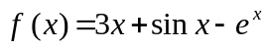 using secant method. The absolute error of functional value at our calculated root should be less than 10⁻³.  - Find out all the possible real roots of the equation x³ – 2x – 5 = 0 using Newton Raphson method to three decimal places. | 7  8
 | - Given the data table  Fit a power function model of the form y = ax^{b}.  - Use suitable interpolation formula to find the value of y(10) from the following data: | 8  7
  X | 1 | 2 | 3 | 4 | 5
  Y | 0.5 | 2 | 4.5 | 8 | 12.5
  x : | 5 | 6 | 9 | 11
  y : | 12 | 13 | 14 | 16
3. | - Evaluate the integral 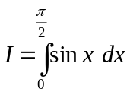. Compare the absolute error in both conditions for Simpson 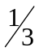 rule and Simpson’s 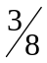 rule.  - Using Gauss-quadrature formula for n = 3, evaluate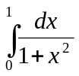. | 8  7
4. | - Solve the following set of equation using L_{u} factorisation method.  3x + 2y + z = 10  2x + 3y + 2z = 14  x + 2y + 3z = 14  - Using factorisation method, solve the following system of linear equations:  3x₁ + 2x₂ + 2x₃ = 10  2x₁ + 3x₂ + 2x₃ = 14  x₁ + 2x₂ + 3x₃ = 14 | 7  8
5. | - Find the value of y(0.4) using Heun’s method, given that y' = y + sinx, y(0) = 1, h = 0.2  - The angular displacement Q of a simple pendulum is given by the equation 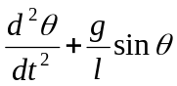= 0 where l = 98 cm and g = 980 cm/sec² if = 0 and 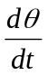 = 4.472 at t = 0. Use Runge Kutta fourth order method to find and when t = 0.2 sec.  OR  Given that 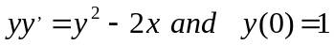. Compute 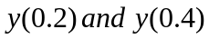 using Runge-Kutta method of the fourth order with 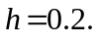 | 7  8
6. | - Solve the Poisson equation 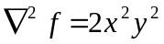 over the square domain 0 ≤ x ≤ 3 and 0 ≤ y ≤ 3 with f = 0 on the boundary and h = 1.  - Find the largest eigen values using power method current up to 2-significant digit.  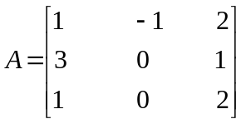 | 8  7
7. | Write short notes on (Any Two):  - Convergence in fixed point iteration method  - Cubic splines  - Euler’s method for solution of differential equation | 2×5

